MSBA Team 9 Group Project Proposal

**Business Problem**

For businesses that offer subscriptions or memberships, it is typically more expensive to generate new customers than it is to retain current customers. For this reason, predicting customer churn is very valuable; customers most likely to end service can be targeted with promotional offers to stay, thus raising revenue, while customers likely to maintain service do not need to be targeted with special offers, lowering costs.

Our dataset comes from a bank experiencing high customer attrition. To address this issue, they need to know what customer attributes are predictive of churn, and thereby, which customers to target with retention offers.

**Modeling Ideas & Data Description**

Our business problem is a supervised classification task: churn or not churn. Our dataset contains historical customer data, including which customers closed their credit card account (our target variable), customer demographic information, account information, and transaction information.

Our dataset is hosted on both Kaggle and LEAPS

(<https://www.kaggle.com/sakshigoyal7/credit-card-customers>)

(<https://leapsapp.analyttica.com/cases/11>)

**Preliminary Data Details**

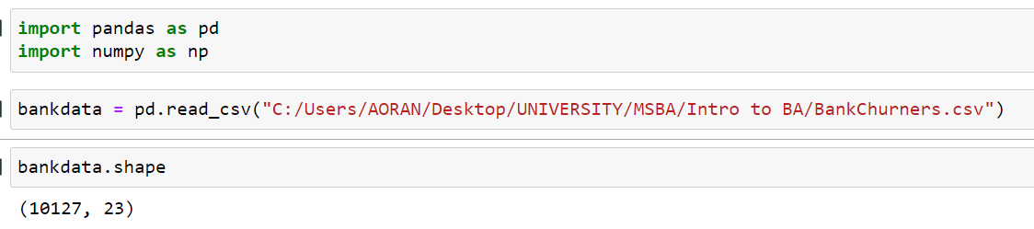

We have 10127 examples in our dataset and 23 variables.

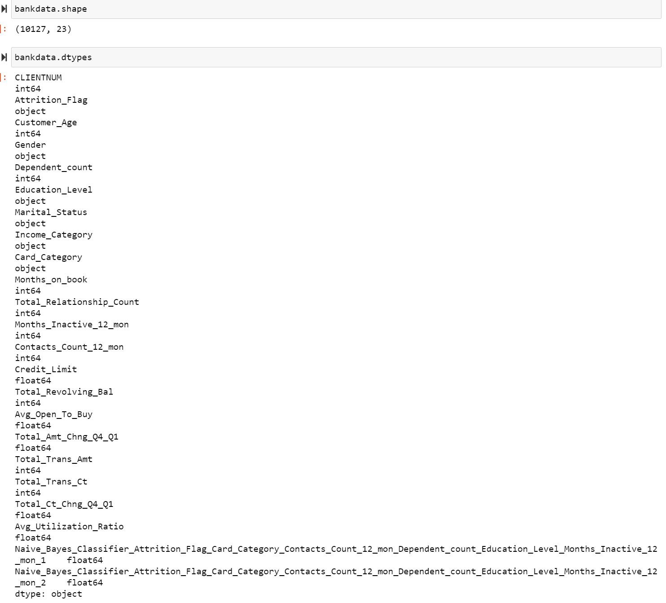

We have 22 variables excluding client number, and the types are in the screenshot above.

The ratio of the most prevalent class is 0.83934

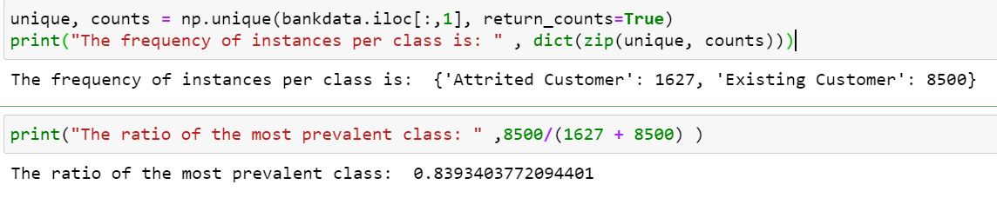

Merchant fee

Interchange fee, a bulk of them goes to bank chase

Credit card association managing account like visa or mastercard

Customer fee including annual, cash advance, balance transfer, and late fees.

Interest

A recent [**survey**](http://www.creditcards.com/credit-card-news/penalty-rate-survey.php) of 100 major U.S. credit cards found that consumers who fall two months behind on their credit card payments face an average penalty interest rate of 28.45%.

[How Credit Card Companies Make and Earn Money - ValuePenguin](https://www.valuepenguin.com/how-do-credit-card-companies-make-money)

Allowance for credit loss 14382

Past due fees $1.3 billion for 2020 and $1.7 billion for 2019 and 2018

Credit card $ 110,634 million

Interchange fee $ 3017 million

Service charges and other customer-related fees . . . . . . . . . . . . . . . . . . . . . . . . . . . . . . 1,243 million

Expense Bankcard, regulatory and other fee assessments $267million

Marketing . . $1,610million

Credit Card . . . . . . . . . . $ 17,599 62 %

The customer rewards reserve, which is included in other liabilities on our consolidated balance sheets, totaled $5.4 billion and $4.7 billion as of December 31, 2020 and 2019, respectively

* [American Express](https://wallethub.com/#american-express): 53.7M cards in circulation
* [Bank of America](https://wallethub.com/#bank-of-america): 55.6M cards in circulation
* [Barclays](https://wallethub.com/#barclays): 16.6M cards in circulation
* [Capital One](https://wallethub.com/#capital-one): 99.7M cards in circulation
* [Chase](https://wallethub.com/#chase): 92M cards in circulation
* [Citibank](https://wallethub.com/#citibank): 70.8M cards in circulation
* [Discover](https://wallethub.com/#discover): 57M cards in circulation
* [Mastercard](https://wallethub.com/credit-cards/mastercard/): 231M cards in circulation
* [Navy Federal Credit Union](https://wallethub.com/credit-cards/navy-federal-credit-union-13308022i): 3.7M cards in circulation
* [Pentagon Federal Credit Union](https://wallethub.com/credit-cards/penfed-credit-union-13307097i): 0.6M cards in circulation
* [PNC](https://wallethub.com/#pnc): 5.4M cards in circulation
* [USAA](https://wallethub.com/#usaa): 8.0M cards in circulation
* [U.S. Bank](https://wallethub.com/#us-bank): 22.3M cards in circulation
* [Visa](https://wallethub.com/credit-cards/visa/): 336M cards in circulation
* [Wells Fargo](https://wallethub.com/#wells-fargo): 24.9M cards in circulation